LAB 2

Theory:

Amplitude Scaling
C x(t) is a amplitude scaled version of x(t) whose amplitude is scaled by a factor C.
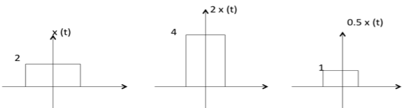

Addition
Addition of two signals is nothing but addition of their corresponding amplitudes. This can be best explained by using the following example:
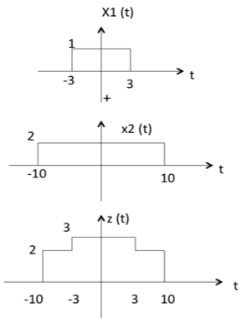
As seen from the diagram above,
-10 < t < -3 amplitude of z(t) = x1(t) + x2(t) = 0 + 2 = 2
-3 < t < 3 amplitude of z(t) = x1(t) + x2(t) = 1 + 2 = 3
3 < t < 10 amplitude of z(t) = x1(t) + x2(t) = 0 + 2 = 2

Subtraction
subtraction of two signals is nothing but subtraction of their corresponding amplitudes. This can be best explained by the following example:
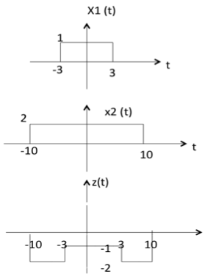
As seen from the diagram above,
-10 < t < -3 amplitude of z (t) = x1(t) - x2(t) = 0 - 2 = -2
-3 < t < 3 amplitude of z (t) = x1(t) - x2(t) = 1 - 2 = -1
3 < t < 10 amplitude of z (t) = x1(t) + x2(t) = 0 - 2 = -2

Multiplication
Multiplication of two signals is nothing but multiplication of their corresponding amplitudes. This can be best explained by the following example:
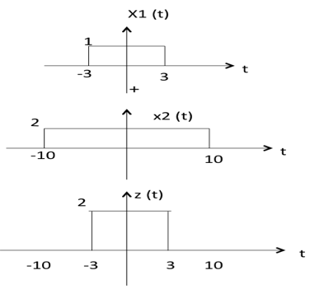
As seen from the diagram above,
-10 < t < -3 amplitude of z (t) = x1(t) ×x2(t) = 0 ×2 = 0
-3 < t < 3 amplitude of z (t) = x1(t) ×x2(t) = 1 ×2 = 2
3 < t < 10 amplitude of z (t) = x1(t) × x2(t) = 0 × 2 = 0
The following operations can be performed with time:

Time Shifting
x(t ±± t₀) is time shifted version of the signal x(t).
x (t + t₀) →→ negative shift
x (t - t₀) →→ positive shift
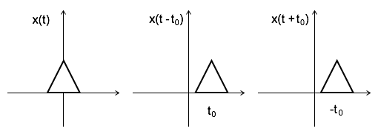

Time Scaling
x(At) is time scaled version of the signal x(t). where A is always positive.
|A| > 1 →→ Compression of the signal
|A| < 1 →→ Expansion of the signal
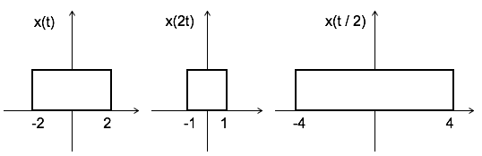
Note: u(at) = u(t) time scaling is not applicable for unit step function.

Time Reversal
x(-t) is the time reversal of the signal x(t).
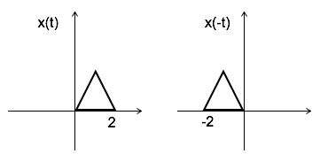

Addition, Substraction and Scaling

clc;
figure(1);

x=[1 2 3 4];
y=[1 1 1 1];
t=0:1:3;
subplot(3,2,1);
stem(t,y);
xlabel("X");
ylabel("Y");
title("signal X [Anjan KC]");

subplot(3,2,2);
stem(t,x);
xlabel("X");
ylabel("Y");
title("signal Y [Anjan KC]");

z=x+y;
subplot(3,2,3);
stem(t,z);
xlabel("X");
ylabel("Y");
title("Signal X+Y [Anjan KC]");

z=x-y;
subplot(3,2,4);
stem(t,z);
xlabel("X");
ylabel("Y");
title("Signal X-Y [Anjan KC]");

a=input("Enter scaling factor:");
z=a*t;
subplot(3,2,5);
stem(z,x);
xlabel("X");
ylabel("Y");
title("Scaled Signal on x axis [Anjan KC]");

z=a*x;
subplot(3,2,6);
stem(t,z);
xlabel("X");
ylabel("Y");
title("Scaled Signal on y axis [Anjan KC]");

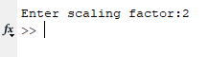
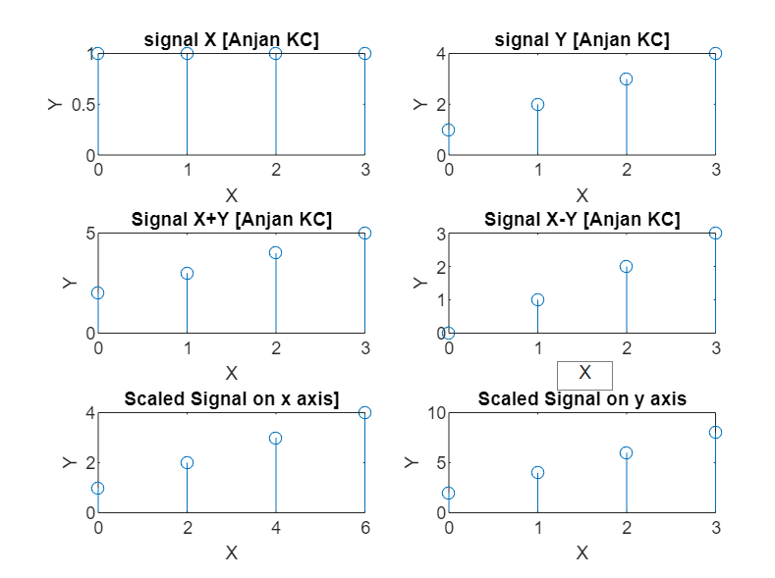

Shifting

clc;
figure(2);

t=-2:1:2;
x=[-2 3 0 1 5];
n1=input("Enter delay amount");
n2=input("Enter advance amount");
subplot(3,2,1);
stem(t,x);
xlabel("X");
ylabel("Y");
title("input signal [Anjan KC]");

m=t+n1;
y=x;
subplot(3,2,2);
stem(m,y);
title("delayed signal [Anjan KC]");

k=t-n2;
z=x;
subplot(3,2,3);
stem(k,z);
title("advance signal [Anjan KC]")

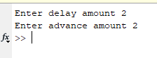
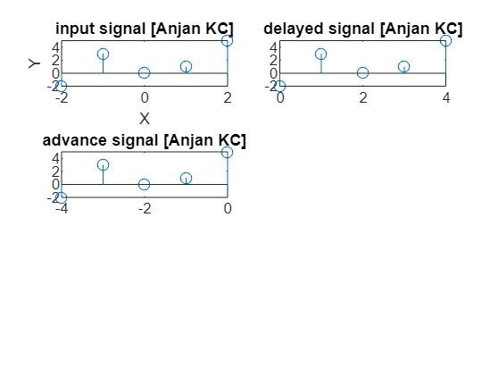

Folding

clc;
figure(3);

n=-1:2;
x=[3,-1,0,-4];
subplot(2,2,1);
stem(n,x);
title('Signal x(n)');

c=fliplr(x);
y=fliplr(-n);
subplot(2,2,2);
stem(y,c);
title('Folded Signal');

